Available online at [www.sciencedirect.com](http://www.sciencedirect.com/)



AASRI Procedia 3 (2012) 474 – 480

2012AASRIConferenceonModeling,IdentificationandControl

Development of Omni Directional Mobile Robot Navigation System using RFID for Multiple Object

M.M. Rashida,1 Nor SaidahbtMohdZainb.2,Faridatunbinti Mohammad Zainc,3

,

*1,2,3Department of Mechatronics Engineering, International Islamic University Malaysia Gombak, Kuala* [*Lumpur.amahbub@iium.edu.my*](mailto:Lumpur.amahbub@iium.edu.my)

**Abstract**

Navigation is an important technique in the field of mobile robotics. A major field of mobile robot system is required to navigate in unknown environments accurately. By determining the positions and selecting a motion control of the robot, navigation is fulfilled through some technique. In this paper, a modular navigation technique in relation with signal from RFID tags, and RFID reader is developed. The main idea is to test the ability of mobile robot to navigate the location in indoor environments. The RFID reader is mounted on the mobile robot to communicate with the RFID tags to determine robot’s position while the RFID tags is are placed at difference location . The position of mobile robot is determined based on the location of RFID tag. The actuator will be move according to the angle between the robot’s current positioned and the target tag.

© 2012 The Authors. Published by Elsevier B.V. Open access under [CC BY-NC-ND license.](http://creativecommons.org/licenses/by-nc-nd/3.0/)

© 2012 Published by Elsevier B.V.

Selection and/or peer review under responsibility of American Applied Science Research Institute

Selection and/or peer review under responsibility of American Applied Science Research Institute

*Keywords: Omni robot; Robot navigation; Reader; transponder*

# Introduction

Mobile robot navigation system has become an appealing challenge in both research and production

industry. It is important due to its ability to navigate the location in unknown environment. Navigation is the ability of a robot to determine its own position in its frame of reference and then find its target location. Navigation can be divided into three main fundamental which are self-localization, path planning and map building.Self-localization means robot’s ability to establish its own position and orientation within the frame of reference. Path planning is effectively an extension of localization, in that it requires the determination of the robot's current position and a position of a goal location while map building can be any notation describing locations in the robot frame of reference.

The aim of this project is to develop Omni Directional Robot Navigation system using RFID for multiple

2212-6716 © 2012 The Authors. Published by Elsevier B.V. Open access under [CC BY-NC-ND license.](http://creativecommons.org/licenses/by-nc-nd/3.0/) Selection and/or peer review under responsibility of American Applied Science Research Institute doi:10.1016/j.aasri.2012.11.075

destinations. Both Omni robot and RFID system must be integrated to each other in the way of controlling the whole system. Omni robot is concerned due to its capability of mechanical manipulator and is capable of tethered and autonomous operation. It also focuses on RFID system which relies on navigation module using customized features of RFID technology. RFID system consists of tags, reader with antenna, and software. When an RFID reader scans the tag, a pulse of radio energy is sent out and the tag sends back the inventory control number.

The objectives of this paper are;

 To design and develop Omni directional mobile robot that can move in indoor environment.  To perform navigation by allocating identification tag at certain located area.

 To develop an efficient algorithm in providing better solution during navigation and to go particular target.

# Methodology

Following is the desired algorithm of mobile robot navigation system to navigate desired location of RFID tag by identifying the angle between the tags and the reader which is mounted on the mobile robot.Navigation elaborates the desired algorithm of mobile robot navigation system to navigate location of RFID tag by identifying the angle between the tags and the reader which is mounted on the mobile robot.

Initially, the robot is pre-programmed with an order list of tag numbers in defining the position of the tag whereas the current target angle is determined by calculating current goal location. When the known ID is achieved, the target transponder is detected through the signal backscattered from all the tags within the communication range. The calculation after input received by the two antennas is recorded and computed using;

*(1)*



The mobile robot is then updating its headed by turn right and left and checked whether the angle between calculated and compass is reached. If not, it will turn until it found the correct angle. If yes, mobile robot is moving forward and detected more points. Mobile robot is then identifying current tag whether it is goal or not. If goal, it will stop. If not it will calculate current to goal angle and compare through continuous loop until it find the goal.

# Omni Robot

The Omni directional mechanismhave three axis and angle (x,y,) movement abruptly in a two dimensional space, which ease to increase robot mobility and more keen access to limited spaces compared withconventional two wheel driven robot [1]. Yukawa et al. further explained that Omni-directional mechanism in the robot consists of four wheel units with a driving mechanism and a steering wheel mechanism. Since the four wheel units drive and steer independently, the position and direction of the mobile robot can be controlled with a high degree of accuracy [2]. Omni robot is becoming technically demanding for users in industrial and business sectors Figure 1. Many Omni robot navigation system products are appearing within medium and long term propositions that lead to development of variety technology advancement in the future. The most common and popular navigation techniques suggested in the state of the art generally fall under one of the following categories: dead-reckoning based, landmark-based, vision based, and behaviour technique based [3].

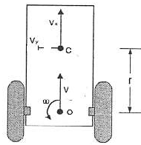

Figure 1: Two wheel mobile robot

# Navigation

The fundamental requirement for mobile robot through navigation is to estimate the position of the autonomous mobile robot. In earlier research, there are several methods used to estimating the robot position for example path planning, trajectory planning, algorithmic exploration and path execution with self- localization. The goal of autonomous robot navigation is built for a system in which dynamically guide and control the mobile robot from its start positions to a predefined end position. According to the previous research, it is state that the robot successfully done their task if the robot can efficiently interpret the data from the sensor [4]. The first method used in previous research is self-localization. This method used the passive RFID tag where placed on the floor. The advantages of this method is that there does not required any information regarding the RFID tag except their ID number. Besides that, this method is used without need for the robot to stop temporarily to observe the RFID tag [5].

In addition, it is required to calculate the distance between the robot and the wall at the time robot passes the specific area to smoothly organize the movement of the robot. Other than that, by using the trajectory planning and path planning, we can estimate the position of the mobile robot. The differences between this method is that the presence of moving and avoiding the obstacle. The path planning used common approach by performing the specific algorithm to determine the shortest path. While for the trajectory planning in the presence of obstacle and find out the path and motion along the path. Furthermore, effective approach can be used by combining the dead reckoning and external sensing by using the metric model. By using the odometry, the approximate current pose can be obtaining but maintain the pose estimate [4].

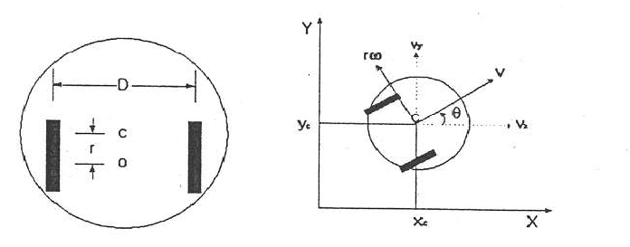

Figure 2: Active–Driving Wheel in Two Dimensions

# Two wheel mobile robot

Omni Directional robot locality is identical by 3-coordinates: position (x, y) and robot direction angle  in an absolute frame. Therobot can mimic the waywhich [5-8] acquired from the current posture (x, y, ) in analignment space. Figure 2 shows an active driving two-wheeled robotwhereC is the centre ofmotion of the robot. The platformscentre of gravity of is at the origin (o), and (Vx, Vy)represents linear speed or tangential velocity, and w is the angular velocity. Here,*r* is the radius of the wheels, and *D* for azimuth length between the wheels [9]. Robot linear speed is defined by the absolute velocity (Vx, Vy) (Cartesian)in the platform

coordinate system at the origin (o), and w for the angular velocity [9-11]. Theta () denotesthe heading angle of the turn in radians. The system is represented in (x, y) coordinate (and orientation) varying with respect to time. At any instant, the x the y coordinates of the robot’s centre point are changing based on its speed and orientation. While the time varying states, the physical laws governs the behaviour of the mobile robot but the

system is time invariant. ….(1), (2), …..(3),   

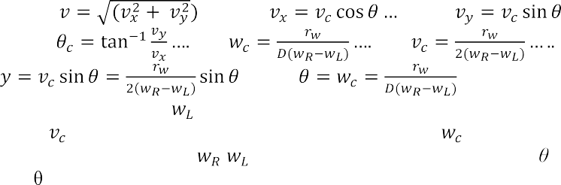

(4)    ….(5), (6), (7), (8), 

…..(9) ….(10) …..(11)

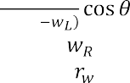

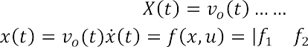Where: = right wheel angular velocity, = left wheel angular velocity,*D* = azimuth distance between the wheels, = wheel radius, = tangential velocity, or linear velocity, and = angular velocity, or steering velocity of the robot. The control inputs = ( , ) and our control outputs = (*X, Y, ).* Therefore, desired trajectory is X (t), Y (t), (t).However, it is difficult to study 3rd order and nonlinearsystem. Some nonlinear equations can be approximated by linear equations under certain conditions. Most of the system behaves like a linear system has a trajectory called the nominal trajectory. In this case chosen conditions for the system behaviour and modelled a linear system are followed. (12),   (13)

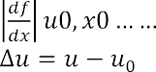

……

(16),

………(20)



.(14),

 (15),

(17), (18)   (19)



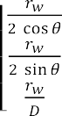……….(21)  (22)

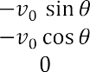

Both wheels have the same initial speed.

# 4 Result

Data from in table 1 are collected to check whether the tag is detected fast or not. This experiment is aimed to verify the counting number of passive tag that can be detected in 5.3 sec at a distance of 1cm.This passive tag can be detected at the range of 150mm.Each trial is tested to check detected tag during navigation. Each trial in figure 4 summarizes the path taken by mobile robot to reach its target.For trial 1 and 2, only five tag is detected, while trial 3, 4, and 6, six tag is detected and both trial 4 and 5, seven tag is detected. This experiment results in random decision path which will be taken by each trial.

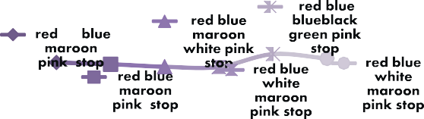Table 1: Numbers of ID tag detect in 5.3 sec

**Trial vs Tag Detected**

|  |  |  |
| --- | --- | --- |
| Trial | Tag Detected(name) | Count |
| 1 | Red | 93 |
| 2 | Stop | 79 |
| 3 | Blue | 82 |
| 4 | Blue black | 84 |
| 5 | Dark blue | 88 |

Figure 3: ID detection for each trial

Several trials as shown in table 2 have been conducted to evaluate time elapse for the mobile robot to reach the goal from the starting point. Each of tag has been named accordingly based on the ID tag positions.

According to figure 5, mobile robot navigation is always updating its angle until it finds the goal. Current heading can be calculated using;

To get exact rotation of mobile robot;





…..(23) ,

…….(26)



…….(28)

……(24),

… (25)

(27)

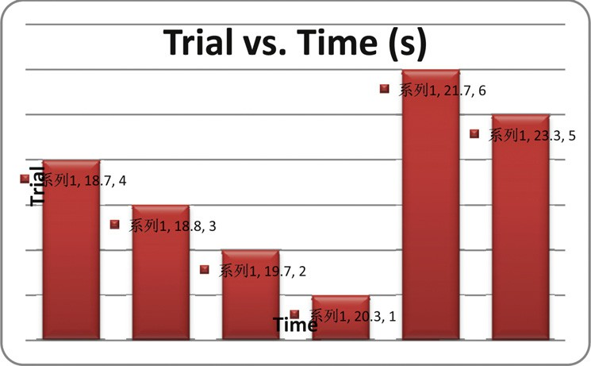

Figure 4: Time elapse to reach goal position

# a) Testing and Evaluation

To verify whether the mobile robot ismoving accordingly and achieved the objectives, several testing

need to be considered literally. At first, programming instruction is uploaded to the microcontroller to turn right if compass angle is greater than heading, turn left if compass angle is less than heading, and move forward when compass angle is equal to heading angle. However, the robot doesn’t move accordingly because the probability for the robot to move forward by ±1 is impossible. Then, the instruction is adjusted by ±3.

The results does not accurately headed the mobile robot to the goal, but in ideal condition the calculation has proved that everything should be in the right track if the procedures is follow accordingly. This might be due to late reaction of RFID antenna to read the tag at time it reached tag. Moreover, the programming is quite long and thus causes delay for looping. During the process, the antenna could not read tag accordingly when it headed to the tag, instead the antenna coils must be at the centre of the tag so that it can read the tag simultaneously. Some reading is missed during navigation process as this problem occurs. This problem happens due to less read range of the reader. Mobile robot somehow didn’t move to the centre of the tag although it reached the tag point. Trials show that possibility to reduce error is when the displacement taken by the mobile robot is closed to the ideal displacement.

# 5. Conclusion

Basic development of this robot has been constructed and tested. Generally, the objectives of this project have been met since the aims are to develop and design the Omni mobile robot used for navigation in indoor environment. The result shows that the prototype model of mobile robot with RFID system is able to be

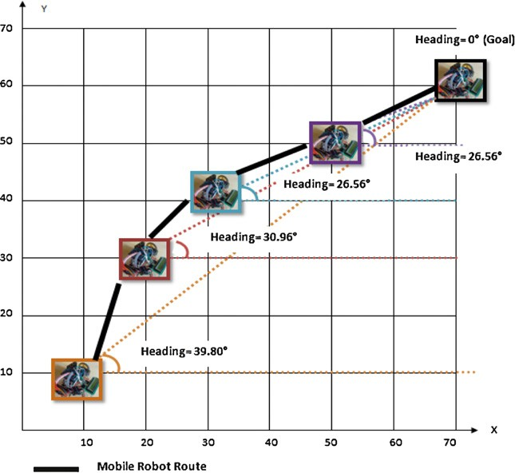applied in real situation. In addition, the position of the mobile robot is determined based on information provided by the tag and the orientation information by the compass while the angle between the robot’s current direction and the target tag is used to provide action to the actuators.Intelligent controller might be applied to the system to reduce an error. Moreover, suitable sensor such as ultrasonic sensor might be used to avoid obstacles in indoor environment.

Figure 5: Navigation path

# References

1. San, K. and Dong H. K., (2007). *A design and implementation of moving object tracking system for omni-directional robot*, International Conference on Control, Automation and Systems 2007 Oct. 17-20, 2007 in COEX, Seoul, Korea, 1790-1793.
2. Yukawa, T., Matsumoto, T., Okano, H., & Hosoya, O. (2006). *Development of an omni-directional mobile robot with two or more cameras and navigation based on cell map information*, 32nd Annual Conference onIEEE Industrial Electronics, IECON 2006, 213-218.
3. Miah, M.S., & Gueaib, W. (2007). *An RFID-Based Robot Navigation System with a Customized RFID Tag Architecture*, 18, 25-30.
4. Feng Lu (2004), *Shape Registration using optimization for mobile robot navigation*, 1-153.
5. Kimuro, Y., Takarabe, S., & Hasegawa, T.(2007). *Machine Learning Approach to Self-Localization of Mobile Robot using RFID Tag*,Advanced intelligent mechatronics, 2007 IEEE/ASME international conference,1-6.
6. Martinussen, E. S., and Arnall, T. (2009). *Designing with RFID*, Proceedings of the Third International Conference on Tangible and Embedded Interaction (TEI'09), Feb 16-18 2009, Cambridge, UK, 343-350.
7. Miah, M.S., & Gueaib, W. (2007), *Intelligent Parallel Parking of a Car- Like Mobile Road Using RFID Technology*, International Workshop on Robotic and Sensors Environments, 1-6.
8. Hae, D.C., Sibum, J., Heejae, J., & Sang, W. A. (2004). Using RFID for Accurate Positioning:*Journal of Global Positioning System*s, 3, 32-39.
9. Nuha.N (2005), *H-Infinity Control Of An Autonomous Mobile Robot*, 1-85.
10. Finkenzeller.K (2003), RFID Handbook: *Fundamentals and Applications in Contactless Smart Cards and Identification*(2nd Ed.),Germany, John Wiley & Sons Ltd.
11. Heesung Chae & Sangik Na (2007). *Mobile Robot Navigation using RFID and Vision Sensor.* 2007 International Symposium on Information Technology Convergence, 52-57.